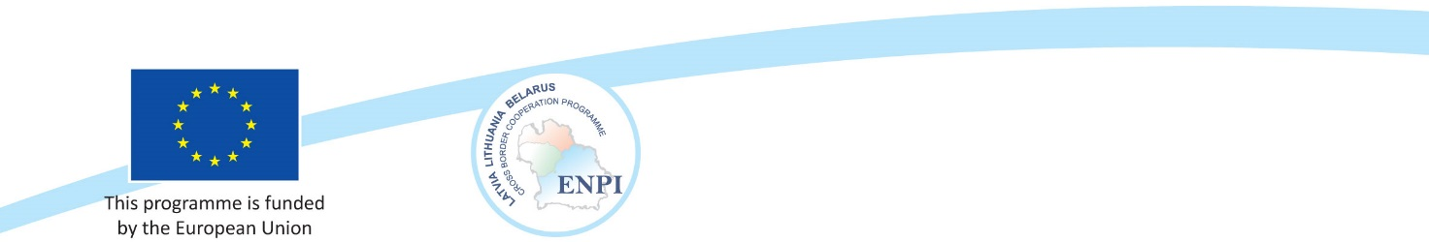

**Latvia, Lithuania and Belarus  
 Cross Border Cooperation Programme**within European Neighborhood and Partnership Instrument 2007-2013

**MANAGEMENT OF ALYTUS-GRODNO REGIONTRANSBOUNDARY**

**PROTECTED AREAS AND PROMOTION OF THEIR INTEGRATION**

**INTO PAN-EUROPEAN ECOLOGICAL NETWORK**

*FINAL PROJECT EVENT*

*December 10–11, 2014*

*Venue: Liškiava Cultural Centre located in Liškiava Monastery Ensemble, Bažnyčios g. 5, LT-65319 Liškiava, Merkinės sen.,Varėnos r. sav.*

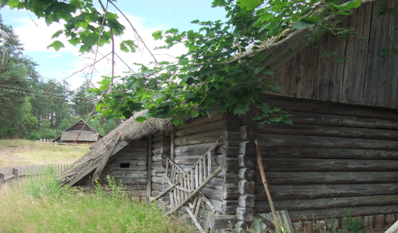

PRELIMINARY PROGRAMME

**10.12.2014**

|  |  |
| --- | --- |
| 9.00-10.00 | Arrival to *Liškiava Cultural Centre, Bažnyčios g. 5, LT-65319 Liškiava, Merkinės sen.,Varėnos r. sav.*  Arrival coffee |
| 10.00-12.00 | *Gediminas Raščius –* Welcome address  *Lina Jankauskienė –* Working together across the border: presentation on project achievements  *Vidmantas Bezaras, Ministry of Environment (to be confirmed)* *–* Regional cooperation as an effective way to better implement the objectives of Ramsar Convention  *Guests from Belarus (to be confirmed)* – On regional cooperation potential.  *Valentin Yatsuhno, BSU –*  Linkages beyond boundaries. The potential of integration of transboundary protected areas of Lithuania and Belarus into Pan-European ecological network |
| 12.00-13.00 | Lunch |
| 13.00-17.00 | *Marijus Pileckas, NHF & Oleg Sozinov, GRSU* *–* Challenges of joint planning. Lessons learned from elaboration of Čepkeliai-Kotra management plan.  *Round table discussion with involvement of conference participants.* How to cooperate in managing transboundary protected areas? Learning from each other.  *Moderation: Oleg Sozinov, GRSU*  *Gennady Dudko, Expert–* Biosphere reserves: an opportunity for cross-border cooperation or headache for national authorities?  *Round table discussion with involvement of conference participants.* The empty seat: how to get key stakeholders into the boat? (National and local authorities, administrations of PAs, local communities, private owners, others)  *Moderation:* *Zenonas Gulbinas, NHF*    *Oleg Sozinov, GRSU* *–* From policies towards practice: protection of nature values in border regions |
| 14.30-15.00 | Coffee |
| 17.00-18.00 | Excursion to the basement exposition of Liškiava church |
| 19.00 | Dinner |

**11.12.2014**

|  |  |
| --- | --- |
| 8.00-9.00 | Breakfast |
| 9.00-12.30 | *Gennady Ozem*, *BGU* - Regional touristic cluster of Belarus-Lithuania transboundary region  *Round table discussion.* Project results, impact and potential for follow up.  *Moderation:* *Lina Jankauskiene*  Questions for consideration:  Assessment of the project results - was there any impact on situation improvement, positive or negative factors that affected implementation of activities, risks faced, sustainability of results, lessons learned? Will and how initiatives continue after end of project? Interest for further cooperation? New ideas for future initiatives? |
| 10.30-11.00 | Coffee |
| 13.00-14.30 | Lunch |
| 15.00-17.00 | Protection of monuments of nature, culture and history. Should Soviet era monuments be preserved? Going to the Grūtas park. |